WELCOME TO BETHEL LUTHERAN CHURCH
Sunday, July 28, 2024, 10th Sunday after Pentecost
Rev. Molly Wills, Pastor | Jan Smith, Accompanist

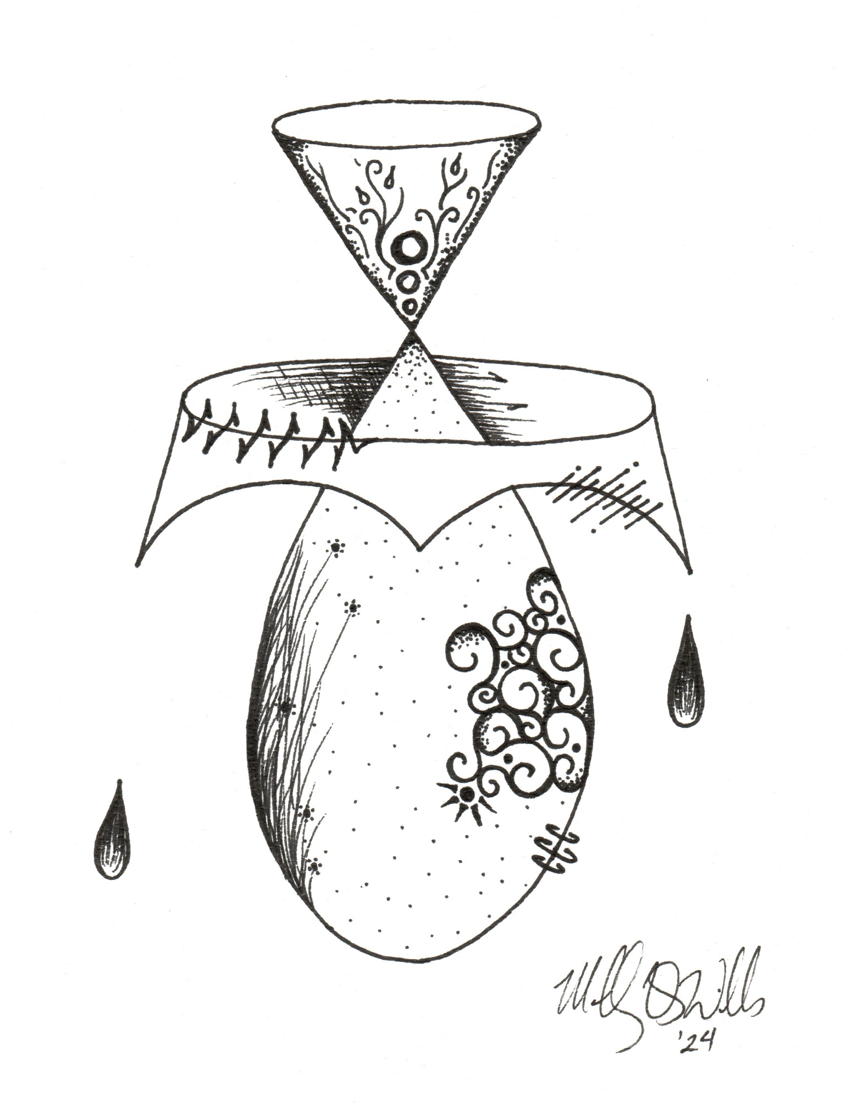
SPIRIT ART
A meditative study of scripture through art.
John 6:1-21

Gathering
The Holy Spirit calls us together as the people of God.

PRELUDE Eat This Bread, Drink This Cup arr. by Mark Albrecht
Let Us Break Bread Together arr. by H. Thomas Manning
We Come to the Hungry Feast arr. by Mark Sedio

WELCOME AND ANNOUNCEMENTS

Confession & Forgiveness
Blessed be the holy Trinity, + one God,
the God of manna,
the God of miracles,
the God of mercy.
Amen.
Drawn to Christ and seeking God’s abundance,
let us confess our sin.
Silence is kept for reflection.
God, our provider,
help us. It is hard to believe there is enough to share.
We question your ways when they differ from the ways
of the world in which we live.
We turn to our own understanding
rather than trusting in you.
We take offense at your teachings and your ways.
Turn us again to you.
Where else can we turn?
Share with us the words of eternal life
and feed us for life in the world.
Amen.
Beloved people of God:
in Jesus, the manna from heaven,
you are fed and nourished.
By Jesus, the worker of miracles,
there is always more than enough.
Through Jesus, + the bread of life,
you are shown God’s mercy:
you are forgiven and loved into abundant life.
Amen.

Gathering Song I Come with Joy (ELW 482)

Greeting (ELW p. 184)
The grace of our Lord Jesus Christ, the love of God,
and the communion of the Holy Spirit be with you all.
And also with you.

Kyrie (ELW p. 184)

Canticle of Praise (ELW p. 187)

Prayer of the Day
Let us pray.
Gracious God, you have placed within the hearts of all your children a longing for your word and a hunger for your truth. Grant that we may know your Son to be the true bread of heaven and share this bread with all the world, through Jesus Christ, our Savior and Lord. Amen.

Word
God speaks to us in scripture reading, preaching, and song.

First Reading: 2 Kings 4:42-44
⁴² A man came from Baal-shalishah, bringing food from the first fruits to [Elisha,] the man of God: twenty loaves of barley and fresh ears of grain in his sack. Elisha said, “Give it to the people and let them eat.” ⁴³ But his servant said, “How can I set this before a hundred people?” So he repeated, “Give it to the people and let them eat, for thus says the Lord, ‘They shall eat and have some left.’ ” ⁴⁴ He set it before them, they ate, and had some left, according to the word of the Lord.
The word of the Lord.
Thanks be to God.

Psalm: 145:10-18
You open wide your hand and satisfy the desire of every living thing. (Ps. 145:16)
¹⁰ All your works shall praise | you, O Lord,
and your faithful | ones shall bless you.
¹¹ They shall tell of the glory | of your kingdom
and speak | of your power,
¹² that all people may know | of your power
and the glorious splendor | of your kingdom.
¹³ Your kingdom is an everlasting kingdom; your dominion endures through- | out all
ages.
You, Lord, are faithful in all your words, and loving in | all your works. R
¹⁴ The Lord upholds all | those who fall
and lifts up those who | are bowed down.
¹⁵ The eyes of all wait upon | you, O Lord,
and you give them their food | in due season.
¹⁶ You open | wide your hand
and satisfy the desire of every | living thing.
¹⁷ You are righteous in | all your ways
and loving in | all your works.
¹⁸ You are near to all who | call upon you,
to all who call up- | on you faithfully. R

Second Reading: Ephesians 3:14-21
¹⁴ For this reason I bow my knees before the Father, ¹⁵ from whom every family in heaven and on earth takes its name. ¹⁶ I pray that, according to the riches of his glory, he may grant that you may be strengthened in your inner being with power through his Spirit, ¹⁷ and that Christ may dwell in your hearts through faith, as you are being rooted and grounded in love. ¹⁸ I pray that you may have the power to comprehend, with all the saints, what is the breadth and length and height and depth, ¹⁹ and to know the love of Christ that surpasses knowledge, so that you may be filled with all the fullness of God.
²⁰ Now to him who by the power at work within us is able to accomplish abundantly far more than all we can ask or imagine, ²¹ to him be glory in the church and in Christ Jesus to all generations, forever and ever. Amen.
The word of the Lord.
Thanks be to God.
Gospel Acclamation (ELW p. 188)

Gospel: John 6:1-21
The holy gospel according to John.
Glory to you, O Lord.
¹ Jesus went to the other side of the Sea of Galilee, also called the Sea of Tiberias. ² A large crowd kept following him, because they saw the signs that he was doing for the sick. ³ Jesus went up the mountain and sat down there with his disciples. ⁴ Now the Passover, the festival of the Jews, was near. ⁵ When he looked up and saw a large crowd coming toward him, Jesus said to Philip, “Where are we to buy bread for these people to eat?” ⁶ He said this to test him, for he himself knew what he was going to do. ⁷ Philip answered him, “Six months’ wages would not buy enough bread for each of them to get a little.” ⁸ One of his disciples, Andrew, Simon Peter’s brother, said to him, ⁹ “There is a boy here who has five barley loaves and two fish. But what are they among so many people?” ¹⁰ Jesus said, “Make the people sit down.” Now there was a great deal of grass in the place; so they sat down, about five thousand in all. ¹¹ Then Jesus took the loaves, and when he had given thanks, he distributed them to those who were seated; so also the fish, as much as they wanted. ¹² When they were satisfied, he told his disciples, “Gather up the fragments left over, so that nothing may be lost.” ¹³ So they gathered them up, and from the fragments of the five barley loaves, left by those who had eaten, they filled twelve baskets. ¹⁴ When the people saw the sign that he had done, they began to say, “This is indeed the prophet who is to come into the world.”
¹⁵ When Jesus realized that they were about to come and take him by force to make him king, he withdrew again to the mountain by himself.
¹⁶ When evening came, his disciples went down to the sea, ¹⁷ got into a boat, and started across the sea to Capernaum. It was now dark, and Jesus had not yet come to them. ¹⁸ The sea became rough because a strong wind was blowing. ¹⁹ When they had rowed about three or four miles, they saw Jesus walking on the sea and coming near the boat, and they were terrified. ²⁰ But he said to them, “It is I; do not be afraid.” ²¹ Then they wanted to take him into the boat, and immediately the boat reached the land toward which they were going.
The gospel of the Lord.
Praise to you, O Christ.

Sermon

Hymn of the Day Loaves Were Broken, Words Were Spoken (ACS 966)

Apostles’ Creed (ELW p. 105)
I believe in God, the Father almighty,
creator of heaven and earth.
I believe in Jesus Christ, God’s only Son, our Lord,
who was conceived by the Holy Spirit,
born of the virgin Mary,
suffered under Pontius Pilate,
was crucified, died, and was buried;
he descended to the dead.*
On the third day he rose again;
he ascended into heaven,
he is seated at the right hand of the Father,
and he will come to judge the living and the dead.
I believe in the Holy Spirit,
the holy catholic church,
the communion of saints,
the forgiveness of sins,
the resurrection of the body,
and the life everlasting. Amen.

Prayers of Intercession
In your mercy,
hear our prayer.

Peace
The peace of Christ be with you always.
And also with you.

Meal
God feeds us with the presence of Jesus Christ.

OfferTORY Shepherd Us by Larry Olson

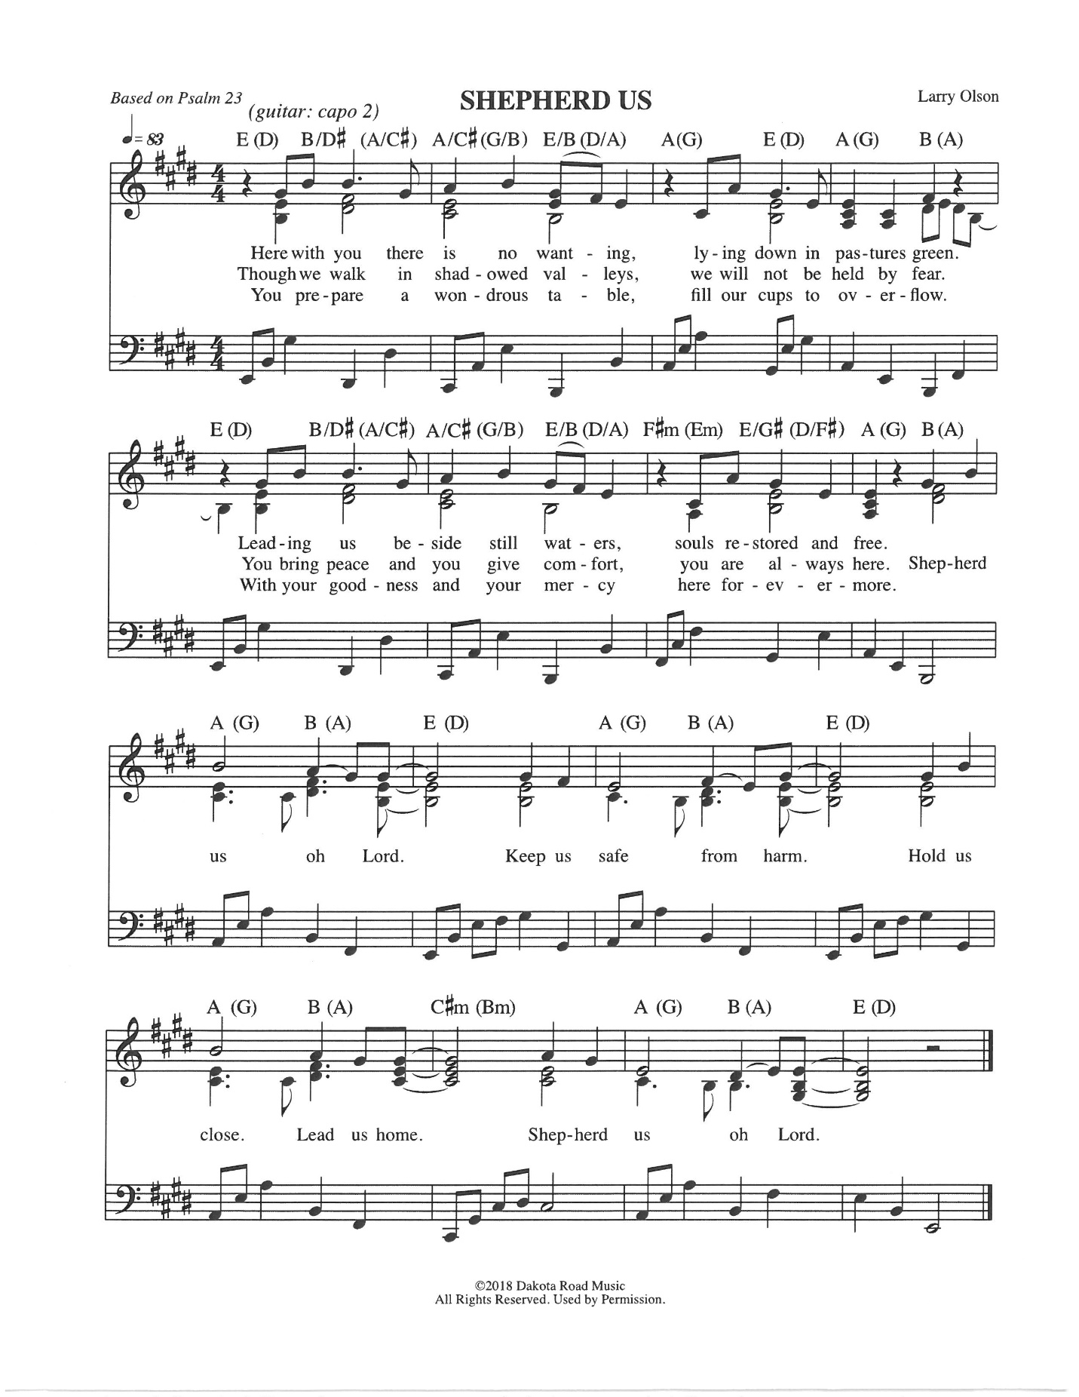

Offering Prayer
Jesus, Bread of life, we have received from your table more than we could ever ask. As you have nourished us in this meal, now strengthen us to love the world with your own life. In your name we pray. Amen.

Great Thanksgiving (ELW p. 190)
The Lord be with you. And also with you.
Lift up your hearts.
We lift them to the Lord.

Let us give thanks to the Lord our God.
It is right to give our thanks and praise.

Preface for the Day (ELW p. 190)

Lord’s Prayer (ELW p. 191)
Gathered into one by the Holy Spirit, let us pray as Jesus taught us.
Our Father in heaven,
hallowed be your name,
your kingdom come,
your will be done,
on earth as in heaven.
Give us today our daily bread.
Forgive us our sins
as we forgive those
who sin against us.
Save us from the time of trial
and deliver us from evil.
For the kingdom, the power,
and the glory are yours,
now and forever. Amen.

Communion (ELW p. 191)

COMMUNION SONG Bread of Life by Larry Olson and Karol Baer
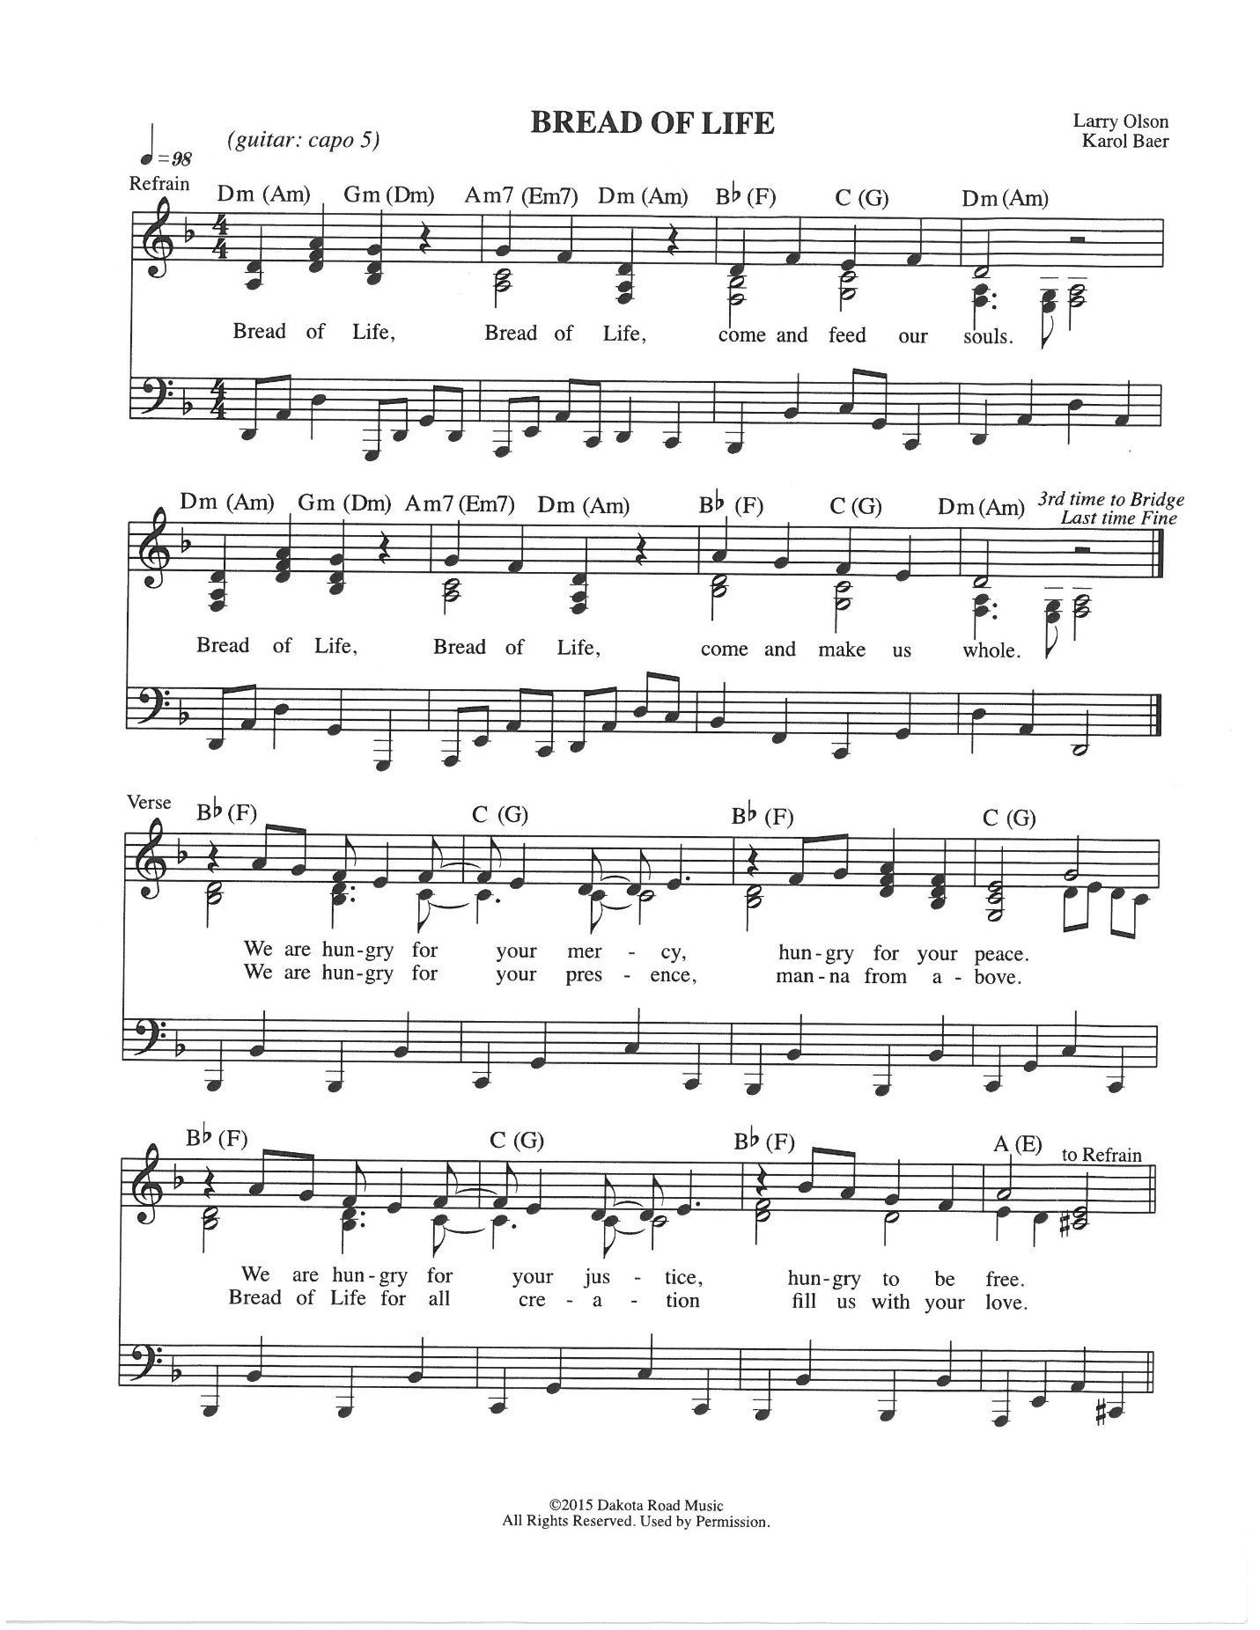

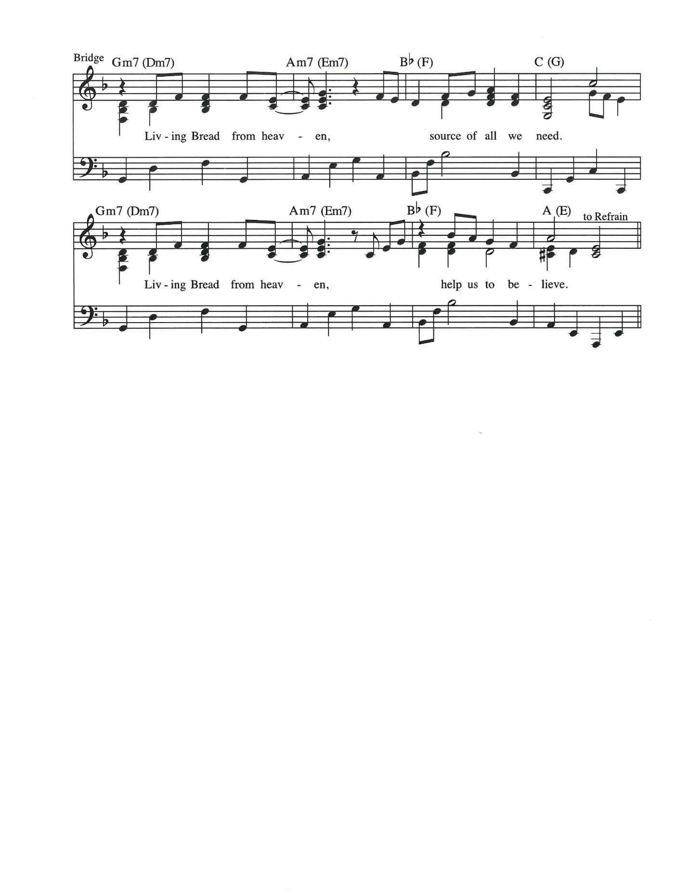

©2015 Dakota Road Music
All rights reserved. Used by Permission.

Prayer after Communion
Jesus, Bread of life, we have received from your table more than we could ever ask. As you have nourished us in this meal, now strengthen us to love the world with your own life. In your name we pray. Amen.

Sending
God blesses us and sends us in mission to the world.

Blessing
The blessing of God, who provides for us, feeds us, and journeys with us, + be upon you now and forever.
Amen.

Sending Song Sent Forth by God's Blessing (ELW 547)

Dismissal
Go in peace. You are the body of Christ.
Thanks be to God.

POSTLUDE Let Us Talents and Tongues Employ arr. by Anne Krentz Organ
From sundaysandseasons.com. Copyright © 2024 Augsburg Fortress. All rights reserved.

BETHEL LUTHERAN CHURCH, ELCA
77 Lincoln AVE N | PO Box 207 | Lester Prairie, MN 55354
www.lpbethel.org | www.facebook.com/lpbethel

OUR MISSION STATEMENT
Vibrantly open to the Spirit, Bethel Lutheran Church seeks to serve God and its neighbors by joyfully living into the good news of Jesus Christ.

QUESTIONS OR REQUESTS?
Please reach out to the church office at 320-395-2125 or bethellutheranlp@gmail.com. For emergency pastoral care needs, please call Pastor Molly Wills at 320-339-8169 or email pastor@lpbethel.org.

BULLETIN SUBMISSIONS DEADLINE: Wednesdays at noon
NEWSLETTER DEADLINE: 25th of the month

HEARING ASSIST DEVICES AVAILABLE: speak to an usher for assistance

SIMPLY GIVING offers convenience for you and much-needed consistency for Bethel! If you are interested in signing up or finding out more, contact Stacy Meyer, Financial Secretary, at finsec@lpbethel.org.

TEXT GIVING: text the dollar amount to 866-298-7547 | ONLINE GIVING: Scan here

THIS WEEK AT BETHEL
Sunday, July 28
- Celebration Bank: Drop your coins in the [piggy] bank and tell us what you’re celebrating! The goal is to raise funds to purchase items from the GLLM Wish List.
- Fellowship Hour: Join us after worship!
Monday, July 29
- Pastor Molly will be out of the office
- No Bible study
Wednesday, July 31
- Quilting: 1:00-4:30 pm
- WELCA meeting: 6:00 pm
Sunday, August 4
- Worship: 9:00 am
- Celebration Bank: Bring your coins to worship and tell us what you’re celebrating!
- Fellowship Hour: Join us after worship!

ANNOUNCEMENTS AND UPCOMING EVENTS

FOR ALL AGES! Dive into the “River of Life” Intergenerational Vacation Bible School, August 5-7, from 5:00-8:00 pm. There will be engaging activities, enriching lessons, and a free meal each night. Volunteers are needed to help make this event a success! Because this event is intergenerational, you do not need to complete a background check to volunteer. Watch for the sign-up sheets for food donations and volunteering with VBS. Scan the posted flyer or go to http://tinyurl.com/VBS2024BethelLP to register. For more details or to sign up to help contact Emily Koehler or Pete Hallberg. Don’t miss out on the fun-see you there!

NATIONAL NIGHT OUT: Bethel will serve ice cream treats on Tuesday, August 6, from 5:00-7:00 pm, at Downtown Square Park on Central Avenue.

POP-UP CHOIR: Sunday, August 11, meet in the sanctuary at 8:15 am to practice.

AUGUST BOOK CLUB: An Immense World by Ed Yong, Discussion date: August 21, 7:00 pm
This book immerses you in an unimaginable realm, offering a glimpse into the world through the eyes of other creatures.

THE LAST FELLOWSHIP BY THE FIRE will be on Wednesday, August 21 beginning at 6:00 pm, around the fire pit. WELCA will supply hotdogs and buns. Please bring a dish to share, your lawn chairs or blanket, and lawn games (optional).

OUTDOOR WORSHIP: Weather permitting, we will worship outside on Sunday, August 25, bring lawn chairs!

PREPARATION FOR BACK-TO-SCHOOL KITS COLLECTION: It’s time to start shopping the school supply sales! WELCA will again have a school supplies collection for LWR to distribute to children worldwide soon. We anticipate using a Thrivent grant to purchase school bags and supplemental supplies. School Kit List: four 70-sheet notebooks, wide or college-ruled, 8 x 10 ^{1/2} paper (no loose-leaf paper) | one 30 cm ruler (or a ruler with centimeters on one side and inches on the other) | one pencil sharpener | one 2 ½” pink eraser | one blunt-point scissors (Fiskars brand) | five ballpoint pens, blue or black ink (no gel ink) | one box of 24 crayons (Crayola brand) | five unsharpened #2 pencils with erasers.

BETHEL WOMEN’S RETREAT: Friday-Sunday, September 13-15, 2024, Medayto Lodge at Green Lake Bible Camp in Spicer, MN. The retreat is for Bethel women of all ages, with their invited friends, relatives, and neighbors. The cost is $75 for the full weekend, which covers lodging, meals, and programming. New for 2024- Saturday only for $50, which covers two meals and programming. Scholarships (full or partial) are available. The deadline to register is August 25. See the display in the narthex for more details of this exciting weekend!

