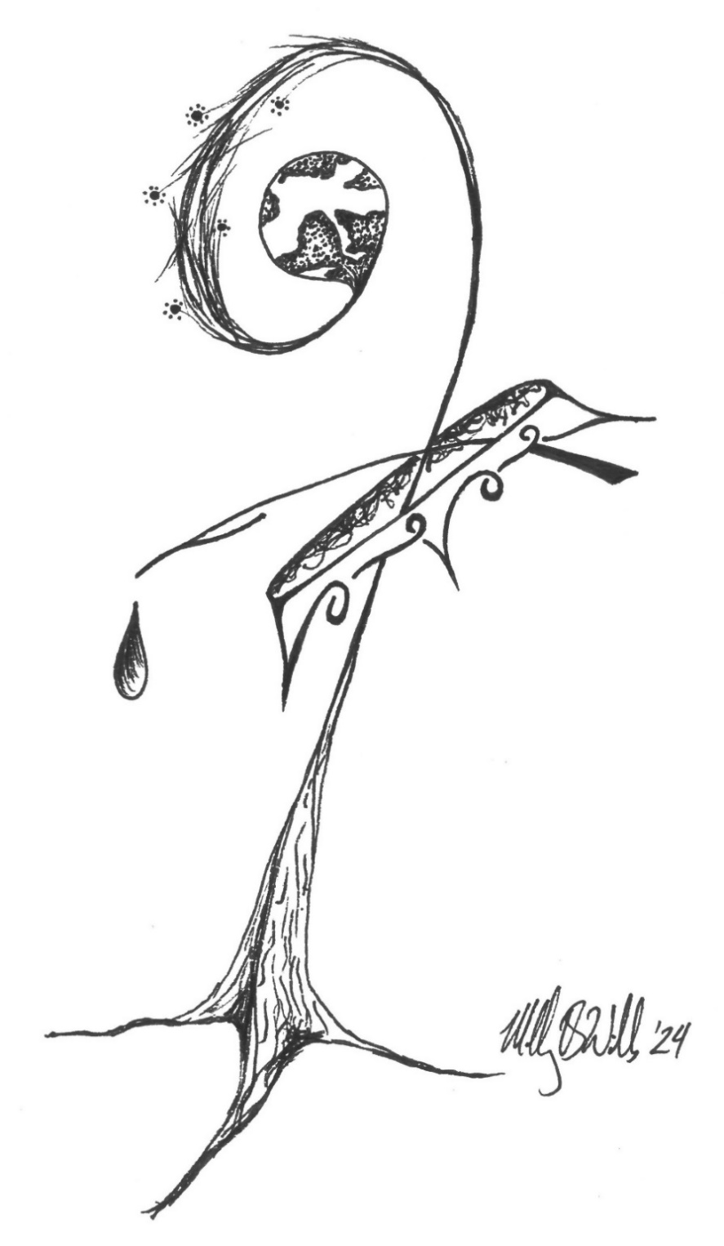
BETHEL LUTHERAN CHURCH
Rev. Molly Wills, Pastor | Jan Smith, Accompanist
Christ the King | Sunday, November 27, 2024
ELW Holy Communion Setting 8

MISSION STATEMENT
Vibrantly open to the Spirit, Bethel Lutheran Church seeks to serve God
and its neighbors by joyfully living into the good news of Jesus Christ.

SPIRIT ART
A meditative study of scripture through art.
John 18:33-37

HELPFUL WORSHIP INFORMATION: We use the Evangelical Lutheran Worship (red book) as our hymnal, containing both liturgy and hymns. Liturgies are indicated by (ELW p. ###), they are found in the front of the hymnal and the numbers are on the bottom of the page. Hymns are indicated by (ELW ###), they are found in the back two-thirds of the hymnal and the numbers are on the top of the page. Hymns in the All Creation Sings hymnal (purple book) are indicated by (ACS ###). Songs in the green binder are indicated by (GB ###).

GATHERING
The Holy Spirit calls us together as the people of God.

Prelude O Worship the King arr. by Melody Bober
Crown Him With Many Crowns arr. by Carol Tornquist
Welcome & Announcements
Confession, Forgiveness, & Thanksgiving
Blessed be the holy Trinity, + one God, our refuge, our delight, our beginning and our end. Amen. Let us come in truth before the one who loves us and has freed us from our sin. Silence is kept for reflection.
Eternal One, robed in majesty and mercy, we confess that sin has taken hold of us and we are complicit in its power. We are disturbed in spirit and our hearts cannot rest. Unbind us and set us free. Lead us again to the waters of rebirth,
that we may live just and generous lives for the good of your world and the care of our neighbors, following in the servant way of Jesus. Amen.
These words are trustworthy and true: Christ bore our sins once, for all, on the cross, swallowing up death forever. For his sake, you are + forgiven and God remembers your sin no more. Let your heart be glad again and rejoice in your salvation. Amen.
For lightening our worries, for embracing us within our faults, and for freeing us, welcoming us into eternal life with you, we thank you, Lord!
For holding us in your heart and hands, for breathing new life into us every day, for inviting us to trust in you to provide, we thank you, Lord!
For those you send to walk with us on our way, for the dear ones you share with us – family, friends, and neighbors, we thank you, Lord!
For your gift of faith, may it burn eternally strong within us, we thank you, Lord!
God’s Beloved Children, let your hearts be glad again and rejoice in your salvation! Amen!
Gathering Song Jesus Shall Reign (ELW 434)
Greeting (ELW p. 184)
The grace of our Lord Jesus Christ, the love of God, and the communion of the Holy Spirit be with you all. And also with you.
Kyrie (ELW p. 184)
Canticle of Praise (ELW p. 185)
Prayer of the Day
Almighty and ever-living God, you anointed your beloved Son to be priest and sovereign forever. Through him, your generous goodness comes to us new every day. By the work of your Spirit lead us to acknowledge your goodness, give thanks for your benefits, and serve you in willing obedience. Grant that all the people of the earth, now divided by the power of sin, may be united by the glorious and gentle rule of Jesus Christ, our Savior and Lord, who lives and reigns with you and the Holy Spirit, one God, now and forever. Amen.

CHOIR Come, Thou Almighty King arr. by Victor C. Johnson
(Congregation, please sing when directed-see music insert)

Word
God speaks to us in scripture reading, preaching, and song.

First Reading: Daniel 7:9-10, 13-14
⁹ As I watched, thrones were set in place, and an Ancient One took his throne;
his clothing was white as snow and the hair of his head like pure wool; his throne was fiery flames, and its wheels were burning fire. ¹⁰ A stream of fire issued and flowed out from his presence. A thousand thousands served him, and ten thousand times ten thousand stood attending him. The court sat in judgment, and the books were opened. ¹³ As I watched in the night visions, I saw one like a human being coming with the clouds of heaven. And he came to the Ancient One and was presented before him. ¹⁴ To him was given dominion and glory and kingship, that all peoples, nations, and languages should serve him. His dominion is an everlasting dominion that shall not pass away, and his kingship is one that shall never be destroyed.
The word of the Lord. Thanks be to God.
Psalm: Psalm 93 (read responsively)
¹ The Lord is king, robed in majesty; the Lord is robed in majesty and | armed with strength. The Lord has made the world so sure that it cannot be moved.
² Ever since the world began, your throne has been established; you are from everlasting.
³ The waters have lifted up, O Lord, the waters have lifted | up their voice; the waters have lifted up their pounding waves.
⁴ Mightier than the sound of many waters, mightier than the breakers of the sea,
mightier is the Lord who dwells on high.
Your testimonies are very sure, and holiness befits your house, O Lord, forever and forevermore.
Second Reading: Revelation 1:4b-8
^{4b} Grace to you and peace from him who is and who was and who is to come and from the seven spirits who are before his throne, ⁵ and from Jesus Christ, the faithful witness, the firstborn of the dead, and the ruler of the kings of the earth. To him who loves us and freed us from our sins by his blood ⁶ and made us a kingdom, priests serving his God and Father, to him be glory and dominion forever and ever. Amen.
⁷ Look! He is coming with the clouds; every eye will see him, even those who pierced him, and all the tribes of the earth will wail on account of him.
So it is to be. Amen. ⁸ “I am the Alpha and the Omega,” says the Lord God, who is and who was and who is to come, the Almighty.
The word of the Lord. Thanks be to God.
Gospel Acclamation (ELW p. 188)
Gospel: John 18:33-37 The holy gospel according to John. Glory to you, O Lord.
³³ Pilate entered the headquarters again, summoned Jesus, and asked him, “Are you the King of the Jews?” ³⁴ Jesus answered, “Do you ask this on your own, or did others tell you about me?” ³⁵ Pilate replied, “I am not a Jew, am I? Your own nation and the chief priests have handed you over to me. What have you done?” ³⁶ Jesus answered, “My kingdom does not belong to this world. If my kingdom belonged to this world, my followers would be fighting to keep me from being handed over to the Jews. But as it is, my kingdom is not from here.” ³⁷ Pilate asked him, “So you are a king?” Jesus answered, “You say that I am a king. For this I was born, and for this I came into the world, to testify to the truth. Everyone who belongs to the truth listens to my voice.”
The gospel of the Lord. Praise to you, O Christ.
Children's Sermon
Sermon
Hymn of the Day O Christ, What Can It Mean for Us (ELW 431)
APOSTLES’ Creed (ELW p. 189)
Prayers of Intercession Merciful God, receive our prayer.
Peace The peace of Christ be with you always. And also with you.


Meal
God feeds us with the presence of Jesus Christ.

Offering Chimes- For the Beauty of the Earth arr. by Patricia Sanders Cota
Offering Prayer
Lord Jesus, our portion and our cup, you offered yourself in love for the world,
and in this meal you nourish us with your life. Fill us with your abundance, that we may feed the hungry and welcome the stranger, trusting in your name. Amen.
Great Thanksgiving
Dialogue (ELW p. 190)
The Lord be with you. And also with you. Lift up your hearts. We lift them to the Lord.
Let us give thanks to the Lord our God. It is right to give our thanks and praise.
Preface (ELW p. 190)
Holy, Holy, Holy (ELW p. 190)
Thanksgiving at the Table (ELW p. 190)
Lord’s Prayer (ELW p. 191)
Communion
Communion Song (ELW p. 191)
Song during Communion O Christ the Same (ELW 760-words only)
Prayer after Communion

Sending
God blesses us and sends us in mission to the world.

Blessing
The Ancient One, enthroned, the Crucified One, now risen, the Indwelling One, poured out, + bless you now and forever. Amen.
Sending Song Lift High the Cross (ELW 660)
Dismissal Go in peace. Encourage one another in Christ. Thanks be to God.
Postlude All Things Now Living arr. Carol Tornquist

From sundaysandseasons.com.
Copyright © 2024 Augsburg Fortress. All rights reserved.

WELCOME TO BETHEL LUTHERAN CHURCH!
QUESTIONS OR REQUESTS? Please contact the church office at 320-395-2125 or bethellutheranlp@gmail.com. For emergency pastoral care needs, please call Pastor Molly Wills at 320-339-8169 or email pastor@lpbethel.org.
BULLETIN SUBMISSION DEADLINE: Wednesdays at noon.
NEWSLETTER DEADLINE: 25th of the month. CHURCH ADDRESS: 77 Lincoln AVE N, Lester Prairie, MN 55354, (Mailing USPS use: PO Box 207)
SIMPLY GIVING offers convenience for you and much-needed consistency for Bethel! If you have any questions, contact Stacy Meyer, Financial Secretary, at finsec@lpbethel.org.
TEXT GIVING: To give text dollar amount to 866-298-7547
ONLINE GIVING: scan QR code
HEARING ASSIST DEVICES AVAILABLE—speak to an usher for assistance.
LARGE PRINT HYMNS AVAILABLE—contact the office if you are interested.
FOR THE WEEK OF NOVEMBER 24, 2024…
Christ the King is a Christian feast day celebrating Jesus’s kingship over the entire universe.
- Worship: 9:00 am with 1st grade Lord’s Prayer Blessing & Recognition
- Sunday school, BLTs, Confirmation class: following worship
- Pie Social: following worship
- Bethel Breakfast will resume in January
Monday, November 25
- No Bible study in November
- Pastor Molly is out of the office
Thursday, November 28 (Happy Thanksgiving!)
Next Sunday, December 1 (First day of Advent)
- Worship: 9:00 am
- Sunday school: following worship (No BLTs)
- Fellowship hour: following worship
ANNOUNCEMENTS AND UPCOMING EVENTS
- November McLeod Emergency Food Shelf Collection: if you haven’t received your special donation envelope, you can still get one today. Place your special donation envelope in the regular offering plate. Checks should be written out to Bethel Lutheran Church. Thank you for your generosity!
- Endowment grants will be accepted through November 30. Yellow applications are on the wall in the narthex. Place completed applications in the Endowment Committee mailbox. The grants will be announced at the annual congregations meeting in Jan.
- Poinsettia sign-up: It is time to order poinsettias to adorn our sanctuary. A sign-up sheet is on the bulletin board. Thank you so much for your participation!
- Advent 2024: Sunday, December 1, 2024, is the first day of Advent. Mid-week Advent Services (Light of the World) will be on December 4, 11, and 18, at 6:30 pm. The Sunday school children will present their Christmas program during worship on Sunday, December 15. A Birthday Party for Jesus will follow worship downstairs in the Fellowship Hall. Christmas Eve Candlelight Worship Service, w/ Holy Communion, starts at 4:00 pm.
- WELCA ADVENT MISSION PROJECT: Bethel WELCA has partnered with the Lester Prairie School Outreach Program to sponsor three local families this year. During Advent, a Christmas Giving Tree will have wish lists (tags) hung on the tree to take and purchase the item listed. On December 15, following worship, we will celebrate with a “Birthday Party for Jesus.” Bring your unwrapped gift to the party; stay for gift wrapping, treats, crafts, and games! All are welcome!
