BETHEL LUTHERAN CHURCH
Rev. Molly Wills, Pastor | Jan Smith, Accompanist
Seventh Sunday after Epiphany | Sunday, February 23, 2025
ACS Holy Communion Setting 11
SPIRIT ART
A meditative study of scripture through art.
Luke 6:27-38
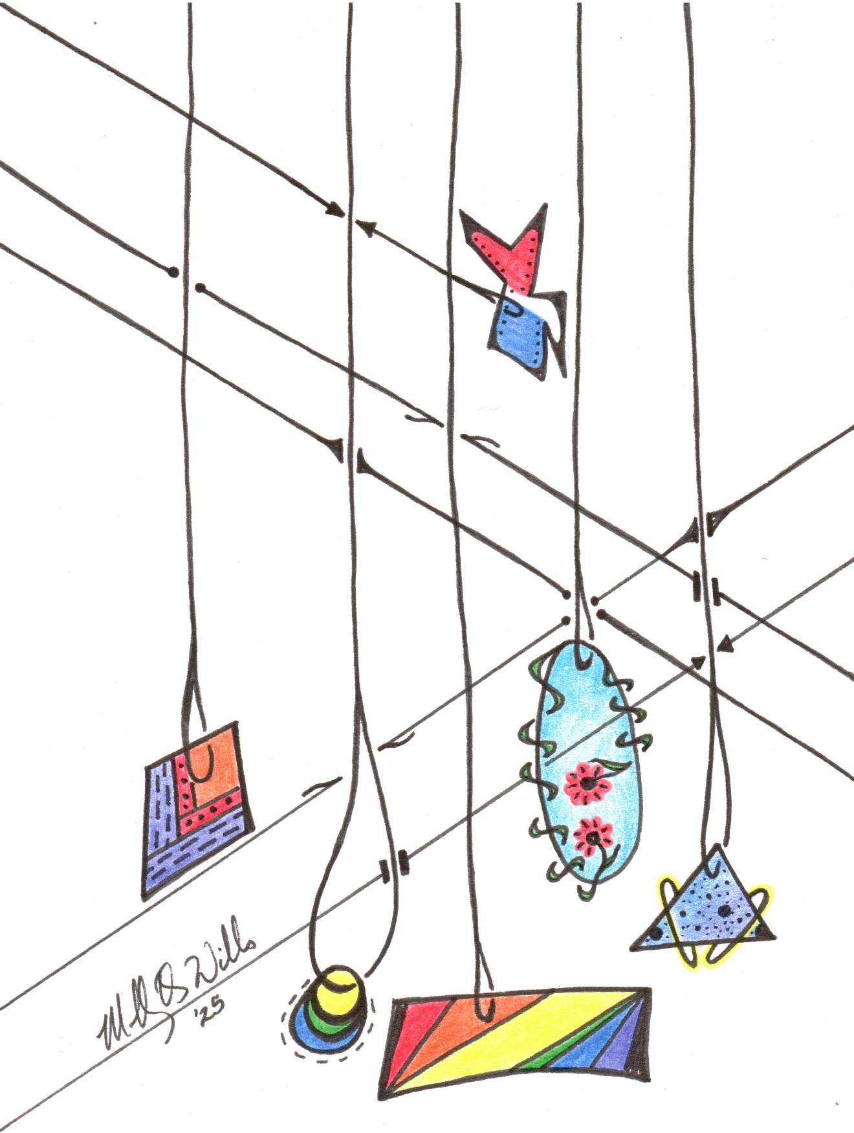

GATHERING
The Holy Spirit calls us together as the people of God.
Meditation time Guide My Feet arr. by Lloyd Larson and Siyahamba arr. by John Carter
Welcome & Announcements
stewardship temple talk: WELCA, Community Garden, Cemetery Committee
Confession, Forgiveness
Blessed be the holy Trinity, + one God, our creator, our protector, our wellspring of life. Amen.
Trusting that God receives our words and the meditations of our hearts, let us confess our sin. Merciful God, you speak blessing and compassion into the world. Forgive us for the ways we act with judgment, cruelty, or indifference. We ignore the needs of our neighbors; we resist your call to oppose injustice; we give in to scarcity and fear; we assume the worst about one another. Cleanse us from our faults and release us from their grasp. Show us your lovingkindness. Restore our hearts and repair your world, that we may live in Christ’s ways. Amen.
God proclaims these words of assurance: “Do not fear, for I have redeemed you. I have called you by name. You are mine.” In + Christ, you are forgiven. In the Spirit, you are made free. Refreshed by the waters of mercy, live anew as beloved children of God. Amen.
GATHERING HYMN We Are Marching in the Light: Siyahamba (red hymnal #866)
Greeting (purple ACS p. 12)
The grace of our Lord Jesus Christ, the love of God, and the communion of the Holy Spirit be with you all. And also with you.
Prayer of the Day
O Lord Jesus, make us instruments of your peace, that where there is hatred, we may sow love, where there is injury, pardon, and where there is despair, hope. Grant, O divine master, that we may seek to console, to understand, and to love in your name, for you live and reign with the Father and the Holy Spirit, one God, now and forever. Amen.
CHOIR Keep Your Lamps arr. by Andre J. Thomas
WORD
God speaks to us in scripture reading, preaching, and song.
FIRST Reading: Genesis 45:3-11, 15
³ Joseph said to his brothers, “I am Joseph. Is my father still alive?” But his brothers could not answer him, so dismayed were they at his presence.⁴ Then Joseph said to his brothers, “Come closer to me.” And they came closer. He said, “I am your brother, Joseph, whom you sold into Egypt. ⁵ And now do not be distressed or angry with yourselves because you sold me here, for God sent me before you to preserve life. ⁶ For the famine has been in the land these two years, and there are five more years in which there will be neither plowing nor harvest. ⁷ God sent me before you to preserve for you a remnant on earth and to keep alive for you many survivors. ⁸ So it was not you who sent me here but God; he has made me a father to Pharaoh and lord of all his house and ruler over all the land of Egypt. ⁹ Hurry and go up to my father and say to him, ‘Thus says your son Joseph, God has made me lord of all Egypt; come down to me; do not delay. ¹⁰ You shall settle in the land of Goshen, and you shall be near me, you and your children and your children’s children, as well as your flocks, your herds, and all that you have. ¹¹ I will provide for you there since there are five more years of famine to come so that you and your household and all that you have will not come to poverty.’” ¹⁵ And he kissed all his brothers and wept upon them, and after that, his brothers talked with him.
Word of God, word of life. Thanks be to God.
Gospel Acclamation (purple ACS p. 14)
Gospel: Luke 6:27-38
The holy gospel according to Luke. Glory to you, O Lord.
[Jesus said:] ²⁷ “But I say to you who are listening: Love your enemies; do good to those who hate you; ²⁸ bless those who curse you; pray for those who mistreat you. ²⁹ If anyone strikes you on the cheek, offer the other also, and from anyone who takes away your coat do not withhold even your shirt. ³⁰ Give to everyone who asks of you, and if anyone takes away what is yours, do not ask for it back again. ³¹ Do to others as you would have them do to you. ³² “If you love those who love you, what credit is that to you? For even sinners love those who love them. ³³ If you do good to those who do good to you, what credit is that to you? For even sinners do the same. ³⁴ If you lend to those from whom you expect to receive payment, what credit is that to you? Even sinners lend to sinners, to receive as much again. ³⁵ Instead, love your enemies, do good, and lend, expecting nothing in return. Your reward will be great, and you will be children of the Most High, for he himself is kind to the ungrateful and the wicked. ³⁶ Be merciful, just as your Father is merciful. ³⁷ “Do not judge, and you will not be judged; do not condemn, and you will not be condemned. Forgive, and you will be forgiven; ³⁸ give, and it will be given to you. A good measure, pressed down, shaken together, running over, will be put into your lap, for the measure you give will be the measure you get back.”
The gospel of the Lord. Praise to you, O Christ.
CHILDREN’S SERMON
SERMON
Hymn of the Day Forgive Our Sins As We Forgive (red hymnal #605)
apostles’ Creed (purple ACS p. 17-18)
Prayers of intercession God of grace, hear our prayer.
Peace The peace of Christ be with you always. And also with you.
MEAL
God feeds us with the presence of Jesus Christ.
offering Nobody Knows the Trouble I’ve Seen/Down to the River to Pray
arr. by Dr. Bragi Thor Valsson (Flute Duet-Terri Helland and Emily Koehler)
OfferING Prayer
God of grace, your love reaches to the heavens, and your abundance to the depths of the seas. Bless what we offer to your service: our gifts, our abilities, and our hearts. Let us overflow with gratitude and generosity, now and always. Amen.
Thanksgiving at the Table
Lord’s prayer (purple ACS p. 24)
COMMUNION
COMMUNION SONG (purple ACS p. 25)
hymn during communion Welcome Table (purple hymnal #969)
Prayer after Communion
SENDING
God blesses us and sends us in mission to the world.
Blessing
The Spirit of the triune God + bless you with joy, anoint you with compassion and send you in love. Amen.
Sending HYMN Guide My Feet (purple hymnal #987)
Dismissal Go in peace. Live in hope. Thanks be to God.
Postlude Give Me Jesus arr. by Michael Ware
From sundaysandseasons.com. Copyright © 2025 Augsburg Fortress. All rights reserved.

NEXT SUNDAY’S READINGS:
Gen 45:3-11,15; Ps 37:1-11, 39-40; 1 Cor 15:35-38, 42-50; Lk 6:27-38

MUSIC NOTES:
Recently, several members of the Bethel choir attended the 2025 Choral Tune-up at Roseville Lutheran Church, which focused on the theme “Healing Through Community.” This event provided an opportunity to immerse themselves in the rich tradition of Black sacred music and the broader music of Black culture, guided by renowned experts Dr. André J. Thomas and Dr. Brandon A. Boyd.
The choir anthem for today, “Keep Your Lamps,” was introduced at the event; it was written by Andre Thomas after he heard a sermon based on the parable found in Matthew 25:1-13.
In addition to the choir selection, most of the music for today was chosen to celebrate the rich contributions of the Black/African American culture to worship.
February is recognized across the nation as Black/African American History Month. During this time, we reflect on the importance of loving our neighbors and seeking justice for them in ways that genuinely restore the missing pieces or broken places in our Christian community. To achieve this, we must first gain understanding and build healthy relationships. (Black History Month Resources by Rev. Carla S. Christopher Wilson-Lower Susquehanna Synod-ELCA)

WELCOME TO BETHEL LUTHERAN CHURCH! WE’RE GLAD YOU’RE HERE!
If you are new to Bethel, here is some helpful worship information: We use the ELW (red hymnal) and the supplement ACS (purple hymnal), which contain liturgy and hymns. Liturgy pages are at the front of each hymnal, with the page numbers at the bottom and in the bulletin as (red ELW p.) or (purple ACS p.) Hymn pages are in the back two-thirds of the hymnals, with the page numbers at the top and in the bulletin as (red hymnal #) or (purple hymnal #). The songs from the Green Book are in the bulletin as (green binder #).
Hearing assist devices are available; speak to an usher for assistance.

MISSION STATEMENT
Vibrantly open to the Spirit, Bethel Lutheran Church seeks to serve God
and its neighbors by joyfully living into the good news of Jesus Christ.

FEBRUARY IS STEWARDSHIP MONTH
Church is not an organization you join; it is a family where you belong,
a home where you are loved, and a hospital where you find healing.

THIS WEEK AT BETHEL
Today, February 23
- Worship: 9:00 am, Stewardship Temple Talk: WELCA, Community Garden, Cemetery
- Sunday school and BLTs (prepare Sunshine Boxes): after worship
- Bethel Breakfast: 10:30 a.m.
Wednesday, February 26
- Bible study: 11:30 a.m.-12:30 p.m.
- Quilting: 1:00 p.m.-4:30 p.m.
- Choir practice: 6:30 p.m.
Sunday, March 2
- Worship: 9:00 a.m.
- Sunday school and confirmation class: after worship
- The Chosen: 10:15 a.m.

QUESTIONS OR REQUESTS? Contact the church office at 320-395-2125 or bethellutheranlp@gmail.com. Call Pastor Molly Wills at 320-339-8169 or email pastor@lpbethel.org for emergency pastoral care needs.
ADDRESS: 77 Lincoln AVE N, Lester Prairie, MN 55354, (Mailing USPS: PO Box 207)
WEBSITE: www.lpbethel.org

FACEBOOK: www.facebook.com/lpbethel
BULLETIN SUBMISSION DEADLINE: Wednesdays at noon
NEWSLETTER DEADLINE: 25th of the month
ONLINE GIVING: scan the QR code
TEXT GIVING: To give, text dollar amount to 866-298-7547
SIMPLY GIVING offers convenience for you and much-needed consistency for Bethel! For more information, contact Stacy Meyer, Financial Secretary, at finsec@lpbethel.org.

ANNOUNCEMENTS AND UPCOMING EVENTS
- LENT BEGINS ON ASH WEDNESDAY: Join us for Ash Wednesday, March 5th worship service at 6:30 p.m. and mid-week Holden Evening Prayer at 6:30 p.m. on Wednesdays March 12-April 9. Meals will be served each week from 5:00 p.m.-6:15 p.m. There is a Lenten meal sign-up sheet in the narthex for anyone who wants to take a turn to organize, prepare, and serve a meal for 35-45 people. Thrivent Action grants will cover the meal expenses. You can also sign up to bring bars or clean up. Ask Diane Horsman if you have any questions. *Watch for the Agape Meal (Maundy Thursday) soup sign-up sheet.
- WELCA LENTEN PROJECT: During Lent, WELCA will collect items for Personal Care Kits for Lutheran World Relief. We ask that you bring a specific item to each mid-week Lenten worship service. The first item to bring on Wednesday, March 12, is a new metal nail clipper (an attached file is optional), please remove the packaging. If you cannot attend on Wednesdays, please note that donations will be accepted anytime during Lent.
- 2025 HUTCHINSON EMPTY BOWLS: Please join us as we celebrate community with food and handmade bowls in Hutchinson. The event will be on Saturday, March 8, from 11:00 a.m.-1:00 p.m., at Hutchinson High School. Empty Bowls will feature handmade bowls made by professionals, hobbyists, and students. The cost of a bowl is a suggested donation of $20.00, but no one will be turned away if they cannot pay. Proceeds will be given to Common Cup Ministry, Inc. and McLeod Emergency Food Shelf. The bowl becomes a keepsake and a reminder of those whose bowls are empty. We are partnering with the Harvest of the Month program, through the school, to offer a soup made with seasonally, locally available ingredients. A few soups will be available for everyone’s enjoyment. Everyone is welcome to this event. There will be a small Silent Auction and a table of items for sale.
- ICE SKATING: The BLTs are going to Waconia for an ice skating outing on Sunday, March 9, from noon to 1:30 p.m. We will leave the church at 11:30 a.m. and expect to return about 2:00 p.m. Attendance is free for BLTs! A participation form is required, but if you attended the Big Stone event, you can use the same form. Please sign up in the narthex or email Terri Helland at terrihelland@gmail.com. This will be an outdoor rink, and skates will be available to rent there. Remember to dress warmly!
- “IS PRAYER YOUR STEERING WHEEL OR YOUR SPARE TIRE?”-Corrie Ten Boom
The Bethel WELCA group is sponsoring and welcoming all women to a Bible study focusing on “Discovering the Power of Prayer” during March. The study will be held on Tuesdays (March 11, 18, and 25) from 6:30 p.m. -7:30 p.m. The first meeting will be held at Diane Horsman’s house. (The location of the second and third dates will be announced. If you have questions, please ask Jan Smith.
- MARCH BOOK CLUB: Murder on the Red River by Marcie Rendon, Discussion: March 19, 7:30 p.m. This gripping mystery follows the life of a young Ojibwe woman as she struggles to come to terms with the callous murder of a Native American stranger, bringing to life the gritty, dark reality of a flawed foster care system and the oppression of Indigenous people.
- LESTER PRAIRIE LIONS COMMUNITY BREAKFAST: Sunday, March 16, from 9:00 a.m. to noon at the City Hall. Serving: pancakes, eggs, sausage, toast, juice, and coffee; free-will offering and proceeds support local Lions projects.

