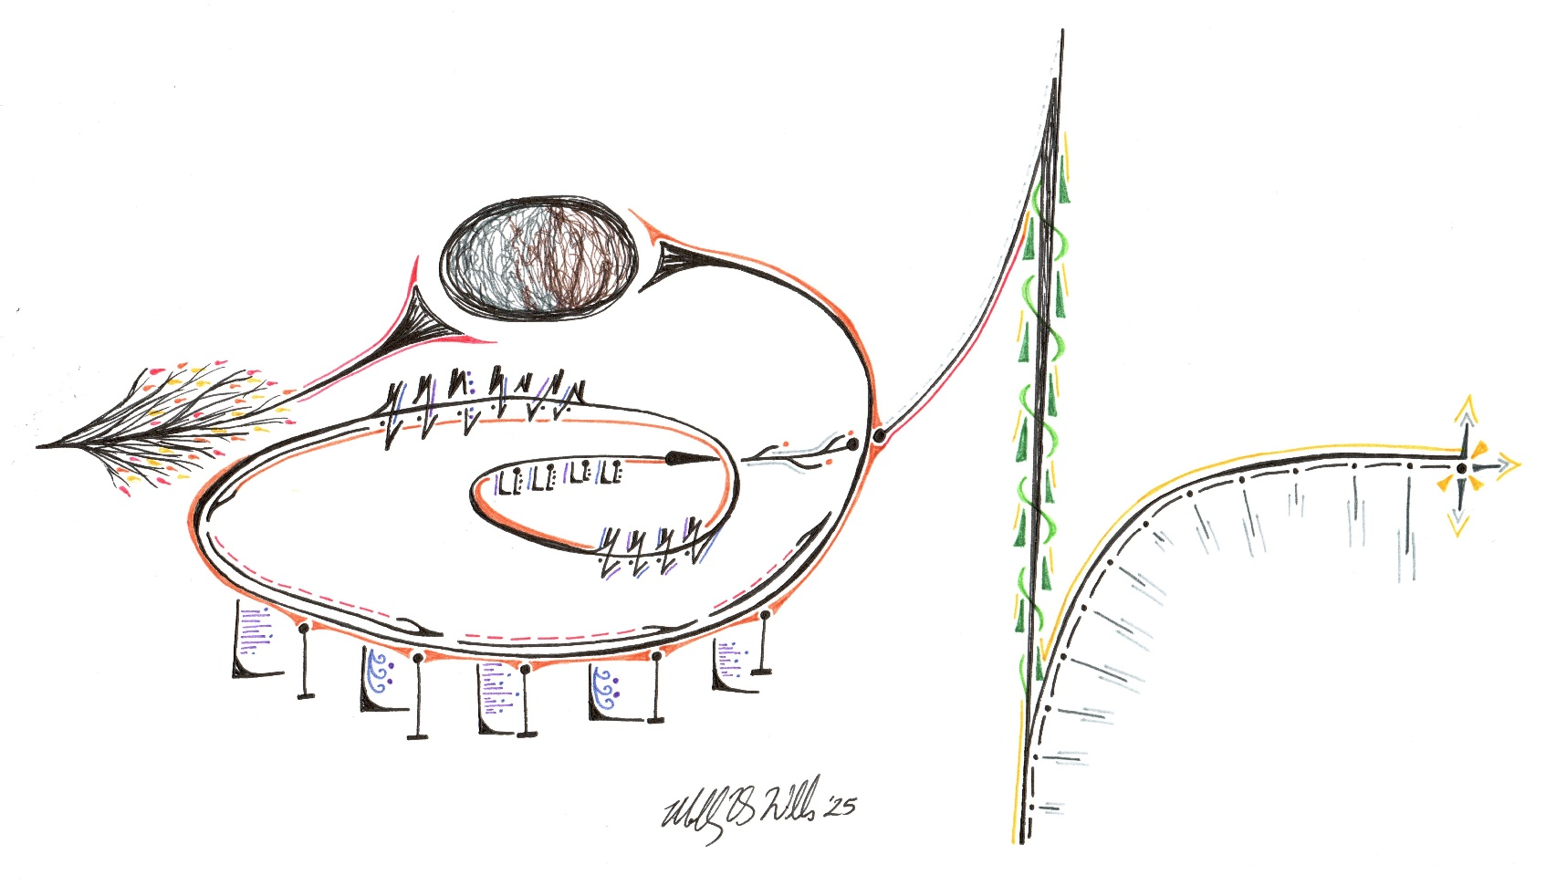
BETHEL LUTHERAN CHURCH
Rev. Molly Wills, Pastor | Jan Smith, Accompanist
First Sunday in Lent | Sunday, March 9, 2025
ELW Holy Communion Setting 10
SPIRIT ART
A meditative study of scripture through art.
Luke

GATHERING
The Holy Spirit calls us together as the people of God.
Meditation time How Deep the Father's Love arr. by Mark Hayes and Marvin Gaspard
Meditation on "Showalter" arr. by David Lasky
Welcome & Announcements
call to worship song Jesus, We Are Gathered (red hymnal #529, sing 2X)
Confession, Forgiveness
Blessed be the holy Trinity, + one God, who forgives all our sin, whose mercy endures forever. Amen. Let us return to God, confessing our sin in the assurance of God’s abiding love. Compassionate One, you are slow to anger and abounding in steadfast love, but our lives do not always reflect you and your love for the world. We do not show others the tender compassion you have shown to us. We do not welcome others with the radical hospitality you grant on all people. We oppress others, even though you have set us free again and again. We squander the abundant gifts of the earth. Transform our lives and guide us again in the way of the cross. Amen.
Beloved in Christ, God’s arms are always stretched open wide to welcome the wandering ones home. In + Christ your sins are forgiven. You have a place in God’s house forever. Amen.
GATHERING SONG What a Fellowship, What a Joy Divine (red hymnal #774)
Greeting (red ELW p. 203)
The grace of our Lord Jesus Christ, the love of God, and the communion of the Holy Spirit be with you all. And also with you.
KYRIE (red ELW p. 203) Have mercy on us, Lord…
CANTICLE OF PRAISE (red ELW p. 204) Glory be to God in heaven…
Prayer of the Day
O Lord God, you led your people through the wilderness and brought them to the promised Land. Guide us now, so that, following your Son, we may walk safely through the wilderness of this world toward the life you alone can give, through Jesus Christ, our Savior and Lord, who lives and reigns with you and the Holy Spirit, one God, now and forever. Amen.
CHOIR Jesus Keep Me Near the Cross arr. by Jonathan Strommen Campbell
WORD
God speaks to us in scripture reading, preaching, and song.
FIRST Reading: Deuteronomy 26:1-11
¹ “When you have come into the land that the Lord your God is giving you as an inheritance to possess and you possess it and settle in it, ² you shall take some of the first of all the fruit of the ground, which you harvest from the land that the Lord your God is giving you, and you shall put it in a basket and go to the place that the Lord your God will choose as a dwelling for his name. ³ You shall go to the priest who is in office at that time and say to him, ‘Today I declare to the Lord your God that I have come into the land that the Lord swore to our ancestors to give us.’ ⁴ When the priest takes the basket from your hand and sets it down before the altar of the Lord your God, ⁵ you shall make this response before the Lord your God: ‘A wandering Aramean was my ancestor; he went down into Egypt and lived there as an alien, few in number, and there he became a great nation, mighty and populous. ⁶ When the Egyptians treated us harshly and afflicted us, by imposing hard labor on us, ⁷ we cried to the Lord, the God of our ancestors; the Lord heard our voice and saw our affliction, our toil, and our oppression. ⁸ The Lord brought us out of Egypt with a mighty hand and an outstretched arm, with a terrifying display of power, and with signs and wonders; ⁹ and he brought us into this place and gave us this land, a land flowing with milk and honey. ¹⁰ So now I bring the first of the fruit of the ground that you, O Lord, have given me.’ You shall set it down before the Lord your God and bow down before the Lord your God. ¹¹ Then you, together with the Levites and the aliens who reside among you, shall celebrate with all the bounty that the Lord your God has given to you and to your house.” The word of the Lord. Thanks be to God.
Psalm: Psalm 91:1-2, 9-16
¹ You who dwell in the shelter of the Most High, who abide in the shadow of the Almighty—
² you will say to the Lord, “My refuge and my stronghold, my God in whom I put my trust.”
⁹ Because you have made the Lord your refuge, and the Most High your habitation,
¹⁰ no evil will befall you, nor shall affliction come near your dwelling.
¹¹ For God will give the angels charge over you, to guard you in all your ways.
¹² Upon their hands they will bear you up, lest you strike your foot against a stone.
¹³ You will tread upon the lion cub and viper; you will trample down the lion and the serpent.
¹⁴ I will deliver those who cling to me; I will uphold them, because they know my name.
¹⁵ They will call me, and I will answer them; I will be with them in trouble; I will rescue and honor them.
¹⁶ With long life will I satisfy them, and show them my salvation.
SECOND READING: Romans 10:8b-13
^{8b} “The word is near you, in your mouth and in your heart” (that is, the word of faith that we proclaim), ⁹ because if you confess with your mouth that Jesus is Lord and believe in your heart that God raised him from the dead, you will be saved. ¹⁰ For one believes with the heart, leading to righteousness, and one confesses with the mouth, leading to salvation. ¹¹ The scripture says, “No one who believes in him will be put to shame.” ¹² For there is no distinction between Jew and Greek; the same Lord is Lord of all and is generous to all who call on him. ¹³ For “everyone who calls on the name of the Lord shall be saved.” The word of the Lord. Thanks be to God.
Gospel Acclamation (red ELW p. 205) We are turning, Lord…
Gospel: Luke 4:1-13 The holy gospel according to Luke. Glory to you, O Lord.
¹ Jesus, full of the Holy Spirit, returned from the Jordan and was led by the Spirit in the wilderness, ² where for forty days he was tested by the devil. He ate nothing at all during those days, and when they were over he was famished. ³ The devil said to him, “If you are the Son of God, command this stone to become a loaf of bread.” ⁴ Jesus answered him, “It is written, ‘One does not live by bread alone.’ ” ⁵ Then the devil led him up and showed him in an instant all the kingdoms of the world. ⁶ And the devil said to him, “To you I will give all this authority and their glory, for it has been given over to me, and I give it to anyone I please. ⁷ If you, then, will worship me, it will all be yours.” ⁸ Jesus answered him, “It is written, ‘Worship the Lord your God, and serve only him.’ ” ⁹ Then the devil led him to Jerusalem and placed him on the pinnacle of the temple and said to him, “If you are the Son of God, throw yourself down from here, ¹⁰ for it is written, ‘He will command his angels concerning you, to protect you,’ ¹¹ and ‘On their hands they will bear you up, so that you will not dash your foot against a stone.’ ” ¹² Jesus answered him, “It is said, ‘Do not put the Lord your God to the test.’ ” ¹³ When the devil had finished every test, he departed from him until an opportune time.
The gospel of the Lord. Praise to you, O Christ.
CHILDREN’S SERMON
SERMON
Hymn of the Day When We Are Tested (purple hymnal #922)
apostles’ Creed (red ELW p. 206)
Prayers of intercession God in your mercy, receive our prayer.
Peace The peace of Christ be with you always. And also with you.
MEAL
God feeds us with the presence of Jesus Christ.
offering I Want to Walk as a Child of the Light arr. by Anne Krentz Organ
(Instrumental Solo - Terri Helland)
OfferING Prayer
Gracious Provider, you set your immense treasures among us, opening your heart to the world. As we prepare to feast on your bountiful love, deepen our commitment to sharing those treasures with others, through our Savior, Jesus Christ. Amen.
GREAT THANKSGIVING
The Lord be with you. And also with you. Lift up your hearts. We lift them to the Lord.
Let us give thanks to the Lord our God. It is right to give our thanks and praise.
PREFACE
HOLY, HOLY, HOLY (red ELW p. 207)
Thanksgiving at the Table
God of our weary years… we proclaim the Lord’s death until he comes.
Christ has died. Christ is risen. Christ will come again.
Remembering, therefore, his death and resurrection… now and forever. Amen.
lord’s prayer (red ELW p. 208)
COMMUNION
COMMUNION SONG (red ELW p. 206) O Lamb of God…
SONG during communion Welcome Table (purple hymnal #969)
Prayer after Communion
SENDING
God blesses us and sends us in mission to the world.
Blessing
God our tender parent, God the crucified one, God the reconciling Spirit, + bless you now and forever. Amen.
Sending SONG As the Winter Days Grow Longer (purple hymnal #924)
Dismissal Go in peace. Care for others as God cares for you. Thanks be to God.
Postlude Even So Come arr. by Carol Tornquist
From sundaysandseasons.com. Copyright © 2025 Augsburg Fortress. All rights reserved.
NEXT SUNDAY’S READINGS: Deut 26:1-11; Ps 91:1-2, 9-16; Rom 10:8b-13; Luke 4:1-13

WELCOME TO BETHEL LUTHERAN CHURCH! WE’RE GLAD YOU’RE HERE!
If you are new to Bethel, here is some helpful worship information: We use the ELW (red hymnal) and the supplement ACS (purple hymnal), which contain liturgy and hymns. Liturgy pages are at the front of each hymnal, with the page numbers at the bottom and in the bulletin as (red ELW p.) or (purple ACS p.) Hymn pages are in the back two-thirds of the hymnals, with the page numbers at the top and in the bulletin as (red hymnal #) or (purple hymnal #). The songs from the Green Book are in the bulletin as (green binder #).
Hearing assist devices are available; speak to an usher for assistance.
MISSION STATEMENT
Vibrantly open to the Spirit, Bethel Lutheran Church seeks to serve God
and its neighbors by joyfully living into the good news of Jesus Christ.

THIS WEEK AT BETHEL
Today, March 9
- Sunday school: after worship
Monday, March 10
- Bible study: 1:30 p.m.
- Council meeting: 6:00 p.m.
Tuesday, March 11
- WELCA Bible study “Discovering the Power of Prayer”: 6:30 p.m. at Diane H.'s home
Wednesday, March 12
- Worship & Music meeting: 12:30 p.m.
- Lenten meal: 5:00 p.m.-6:15 p.m. (serving a variety of soup and bars)
- Choir practice: 5:45 p.m.
- Holden Evening Prayer: 6:30 p.m. (Personal Care Kit item: a new metal nail clipper)
Thursday, March 13
- MEFS Mobile Outreach Bus: 1:30 p.m.-3:00 p.m., Bethel’s parking lot
Sunday, March 16
- Worship: 9:00 a.m.
- Sunday school & Confirmation class: after worship
- The Chosen: 10:15 a.m.
QUESTIONS OR REQUESTS? Contact the church office at 320-395-2125 or bethellutheranlp@gmail.com. Call Pastor Molly Wills at 320-339-8169 or email pastor@lpbethel.org for emergency pastoral care needs.
ADDRESS: 77 Lincoln AVE N, Lester Prairie, MN 55354, (Mailing USPS: PO Box 207)
WEBSITE: www.lpbethel.org

FACEBOOK: www.facebook.com/lpbethel
BULLETIN SUBMISSION DEADLINE: Wednesdays at noon
NEWSLETTER DEADLINE: 25th of the month
ONLINE GIVING: scan the QR code
TEXT GIVING: To give, text dollar amount to 866-298-7547
SIMPLY GIVING offers convenience for you and much-needed consistency for Bethel! For more information, contact Stacy Meyer, Financial Secretary, at finsec@lpbethel.org.

ANNOUNCEMENTS AND UPCOMING EVENTS
- MID-WEEK HOLDEN EVENING PRAYER: Join us for worship at 6:30 p.m. on Wednesdays Mar. 12-Apr. 9. There are still two evenings left to share your faith story during a mid-week Lenten worship service! Sign up on the bulletin board! Meals will be served each week from 5:00 p.m.-6:15 p.m. There are still spots to sign up to bring bars or help clean up. Ask Diane Horsman if you have any questions. (A sign-up sheet is posted on the bulletin board for bringing a pot of soup for the Maundy Thursday Agape meal on April 17th!)
- WELCA LENTEN PROJECT: During Lent, WELCA will collect items for Personal Care Kits for Lutheran World Relief. We ask that you bring a specific item to each mid-week Lenten worship service. The first item to bring on Wednesday, March 12, is a new metal nail clipper (an attached file is optional), please remove the packaging. If you cannot attend on Wednesdays, please note that donations will be accepted anytime during Lent.
- “IS PRAYER YOUR STEERING WHEEL OR YOUR SPARE TIRE?”-Corrie Ten Boom
The Bethel WELCA group is sponsoring and welcoming all women to a Bible study focusing on “Discovering the Power of Prayer” during March. The study will be held on Tuesdays (March 11, 18, and 25) from 6:30 p.m.-7:30 p.m. at Diane Horsman’s house. (The location of the second and third dates will be announced. If you have questions, please ask Jan Smith.
- BOOK CLUB: Murder on the Red River by Marcie Rendon, Discussion: 3/19, 7:30 p.m.
- COMMUNITY GARDEN PLANNING MEETING: Sunday, March 23, immediately following the worship service. Anyone interested in helping with the garden or has ideas to expand our outreach to the community is welcome to attend. Please, contact Emily Koehler or Pete Hallberg with any questions.
- PAINT FACTORY EVENT: Ladies 15 years and older, please join us for a private event at the Paint Factory in Hutchinson on Monday, April 21 at 6:30 p.m. You do not need to be a member of Bethel to participate. Cost: Early Bird special is $25 for the first 15 people who sign up and pay by April 1. After 15 people have signed up, the cost will be $35. Please make your checks payable to “Bethel WELCA” and give them to Jill Duncan. Supplies included are a 16 x 20 canvas, paint, easel, brushes, an apron, and an instructor. Thanks to a Thrivent Action Team grant and WELCA for making this fun outing affordable. (The regular fee is $40 per painter.)
- CROW RIVER CONFERENCE WELCA SPRING GATHERING-SATURDAY, APRIL 26: “Rejoicing in the Lord Always,” featuring the SW MN Youth Band directed by Pastor Hans Peterson, Ev. Lu Church in Cokato. For more information and the sign-up sheet, go to the WELCA area on the bulletin board. Please, give your $12 fee to Jill Duncan by April 13.
- MCLEOD EMERGENCY FOOD SHELF MARCH CAMPAIGN: Now through April 6, 2025, is the Minnesota March FoodShare Campaign! With your help, McLeod Emergency Food Shelf can continue to provide vital services and support those in need. Every little bit helps, so please consider donating today. Go to mcleodemergencyfoodshelf.org to donate or mail your donation to 719 13th ST E, Glencoe, MN 55336 or 498 Hwy 7 E, Hutchinson, MN 55350.
- TOOL COLLECTION: We are working with River of Life Church, Winsted, to collect non-electric hand tools (new or gently used) suitable for reconstruction without electricity. The tools are for the victims of Hurricane Helene in North Carolina. The collection box is at the juncture of the stairs in the entryway. If you have questions, ask Pastor Molly.

